Lab Exercise 1- Docker Fundamental Commands

Objective

Learn and practice the fundamental Docker CLI commands to:
- Manage images and containers
- Understand container lifecycle
- Build and run applications using Docker

Setup Prerequisit es
  - Docker installed on your system

(Check using: docker --version)
  - Internet access to pull images

Basic Docker Commands Step 1: Verify Installation
docker --version
docker info
Expected Output: Docker version and system details.

OUTPUT :-

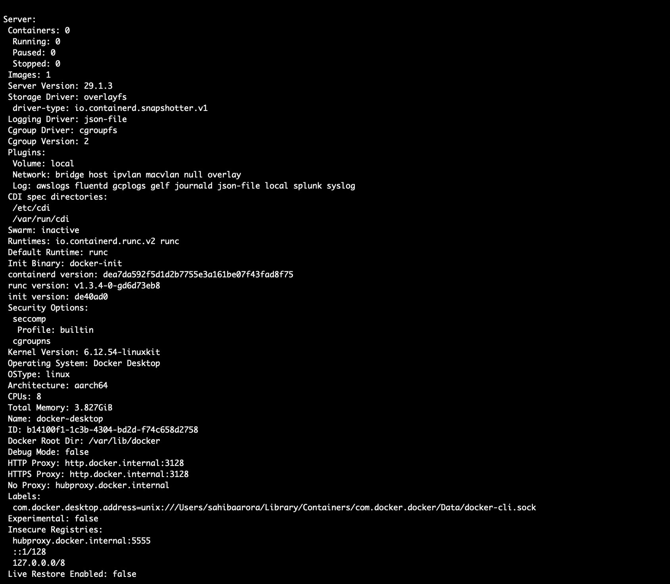
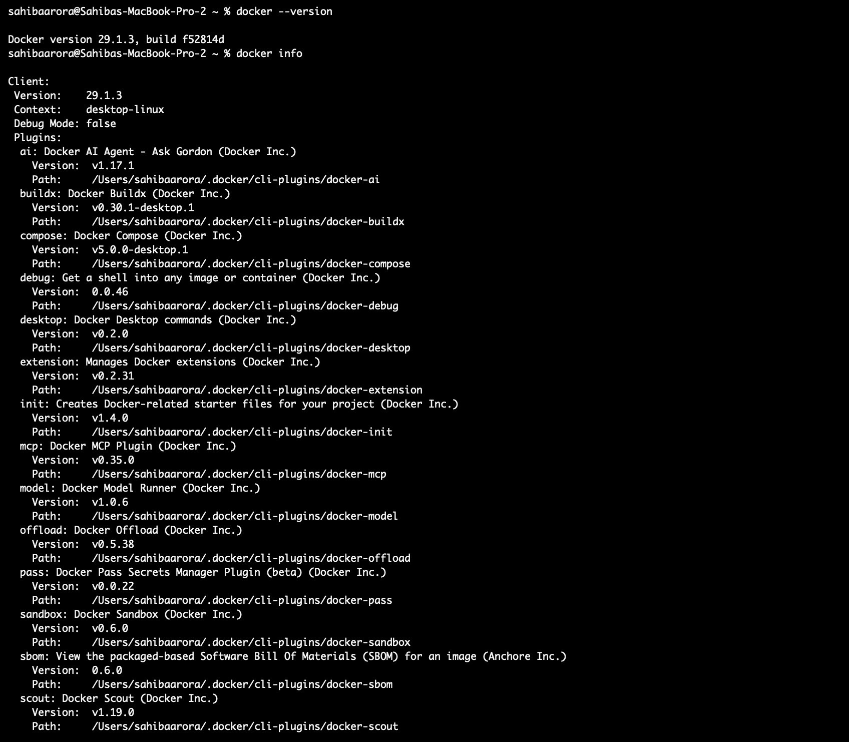

Step 2: Pull an Image from Docker Hub
docker pull ubuntu:latest
Explanation: Downloads the latest Ubuntu image from Docker Hub.

OUTPUT :-
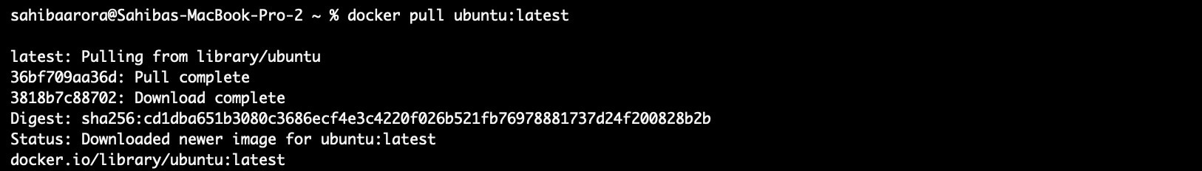

Check available images:
docker images

OUTPUT :-

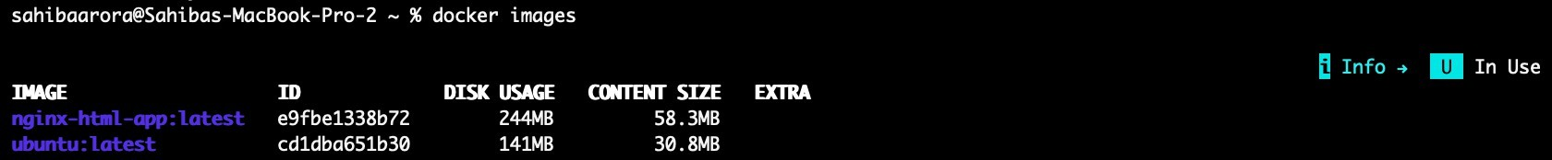

Step 3: Run a Container

Run Ubuntu interactively:
docker run -it --name myubuntu ubuntu bash

Now you’re inside a running container (prompt will change). Exit:
exit

OUTPUT :-

Step 4: List Containers
- Show running containers:
docker ps
- Show all containers (including stopped):
docker ps -a

OUTPUT :-
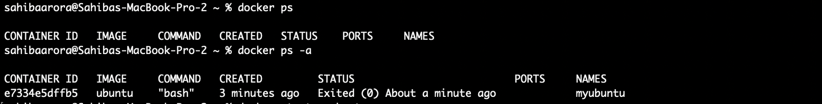

Step 5: Start / Stop / Remove Containers
# Start a stopped container docker start <container_id> # Stop a running container docker stop <container_id> # Remove a container
docker rm <container_id>
Tip: Use docker ps -a to get container IDs.

OUTPUT :-

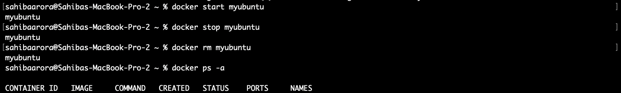

Step 6: Remove Images
docker rmi ubuntu:latest
Note: You must stop and remove all containers using that image first.

OUTPUT :-

